|  |
| --- |
| Sunday 5/12/2021 |

|  |
| --- |
| Brick Breaker Game |

# About the project

Brick Breaker is a game which the player must smash a wall of bricks by deflecting a bouncing ball with a paddle, The paddle may move horizontally and is controlled with the help of arrow keys on the keyboard or touchpad.

The player gets 3 lives to start with, a life is lost if the ball hits the bottom of the screen, If all lives are lost, the game is over. If all the bricks have been destroyed a congratulation message will appear on the screen.

1. This project consists of 4 classes all will covered in next pages
2. Here is the link for this project <https://github.com/daijtt/Brick-breaker-game>
3. Have fun while you are playing

|  |
| --- |
| This project prepared by Presented to |

Dai Alharbi - 392206362 Dr.Meshaiel Alsheail

Tahani Alharbi - 381211654

Yara Alwatban 411202020

Juri Alhazaai 411202021

|  |
| --- |
| Ball.java |

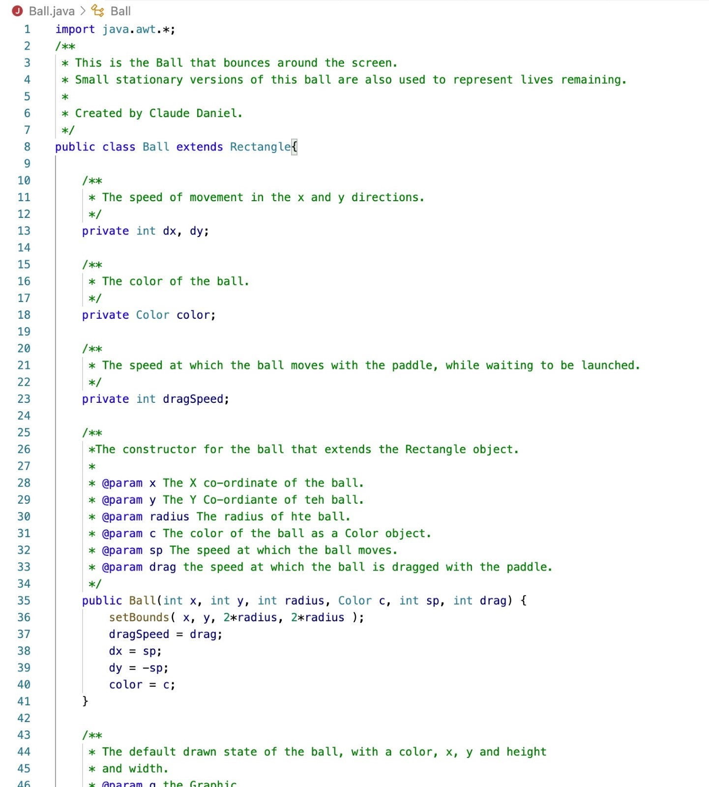

|  |
| --- |
| Ball.java |

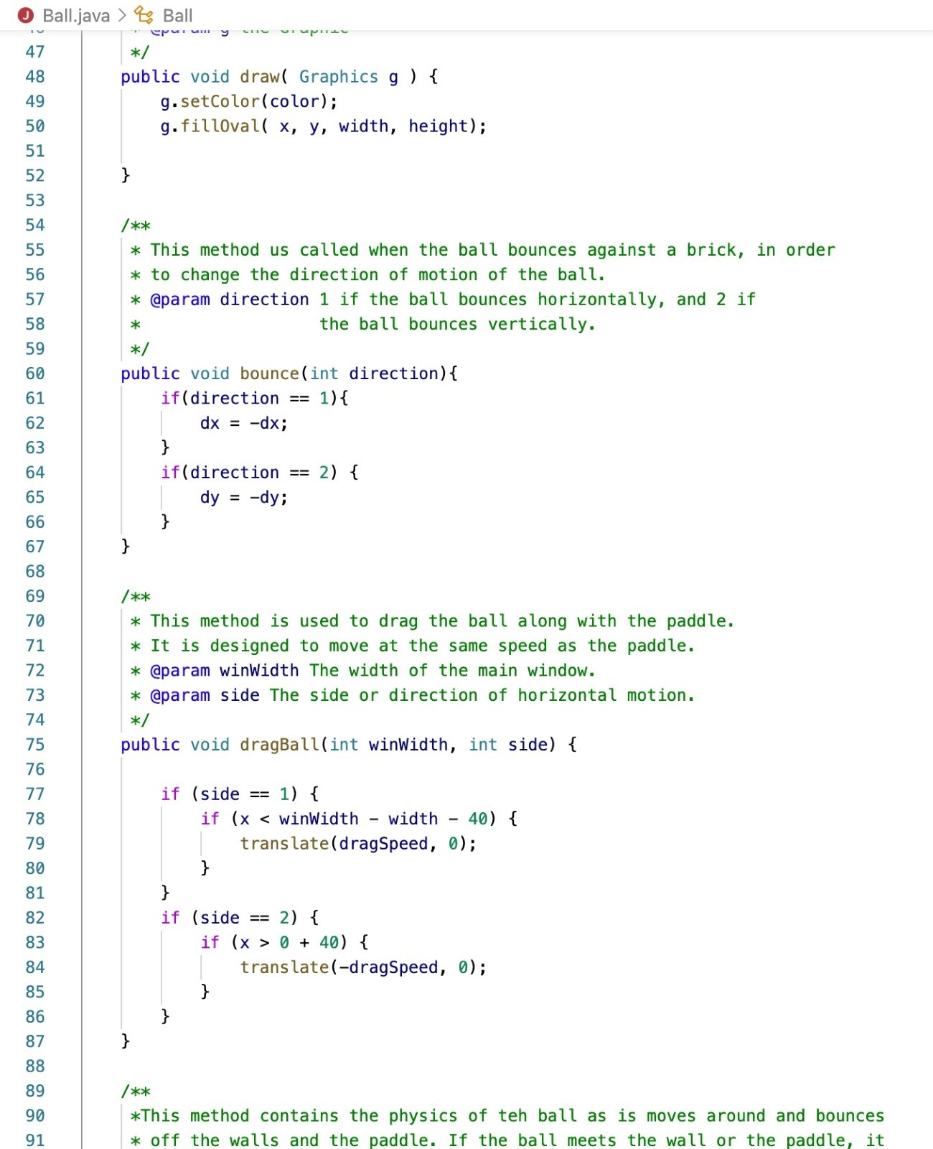

|  |
| --- |
| Ball.java |

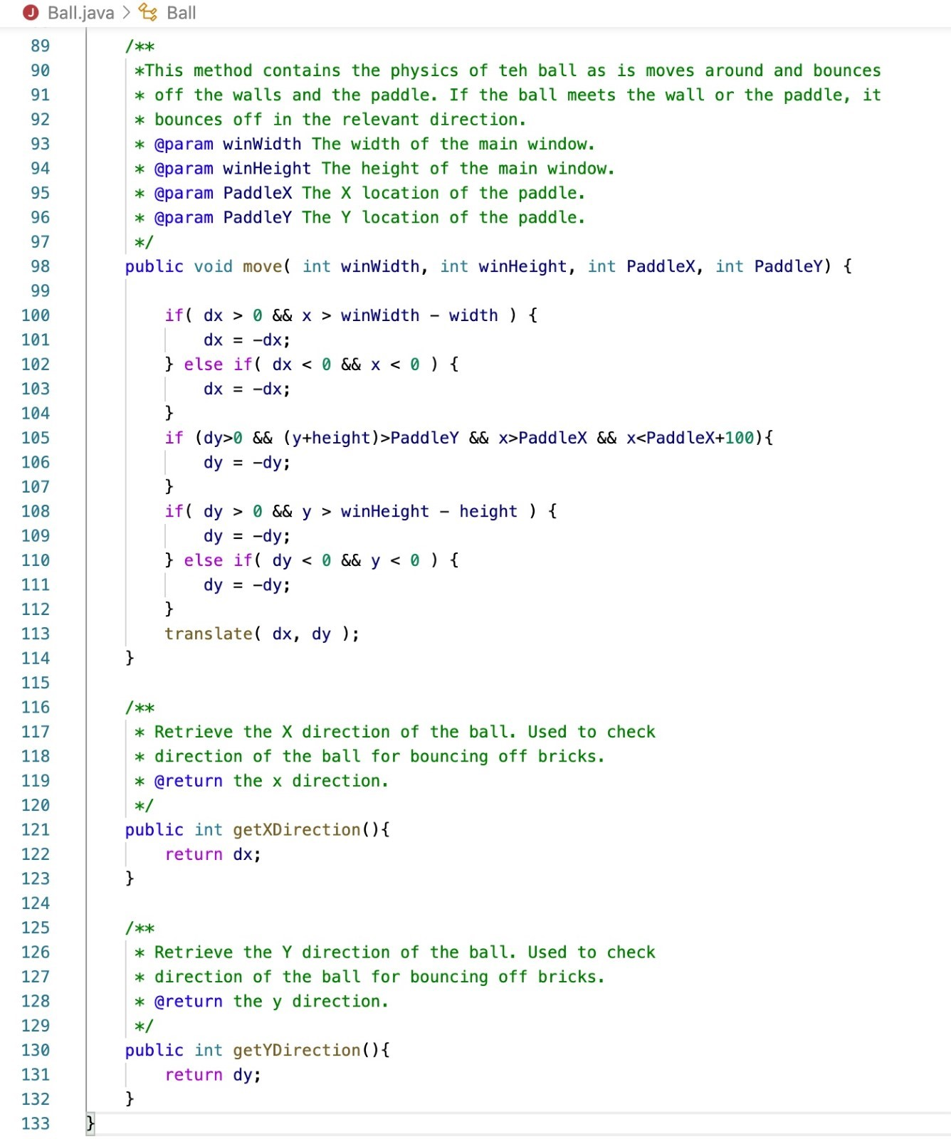

|  |
| --- |
| Block.java |

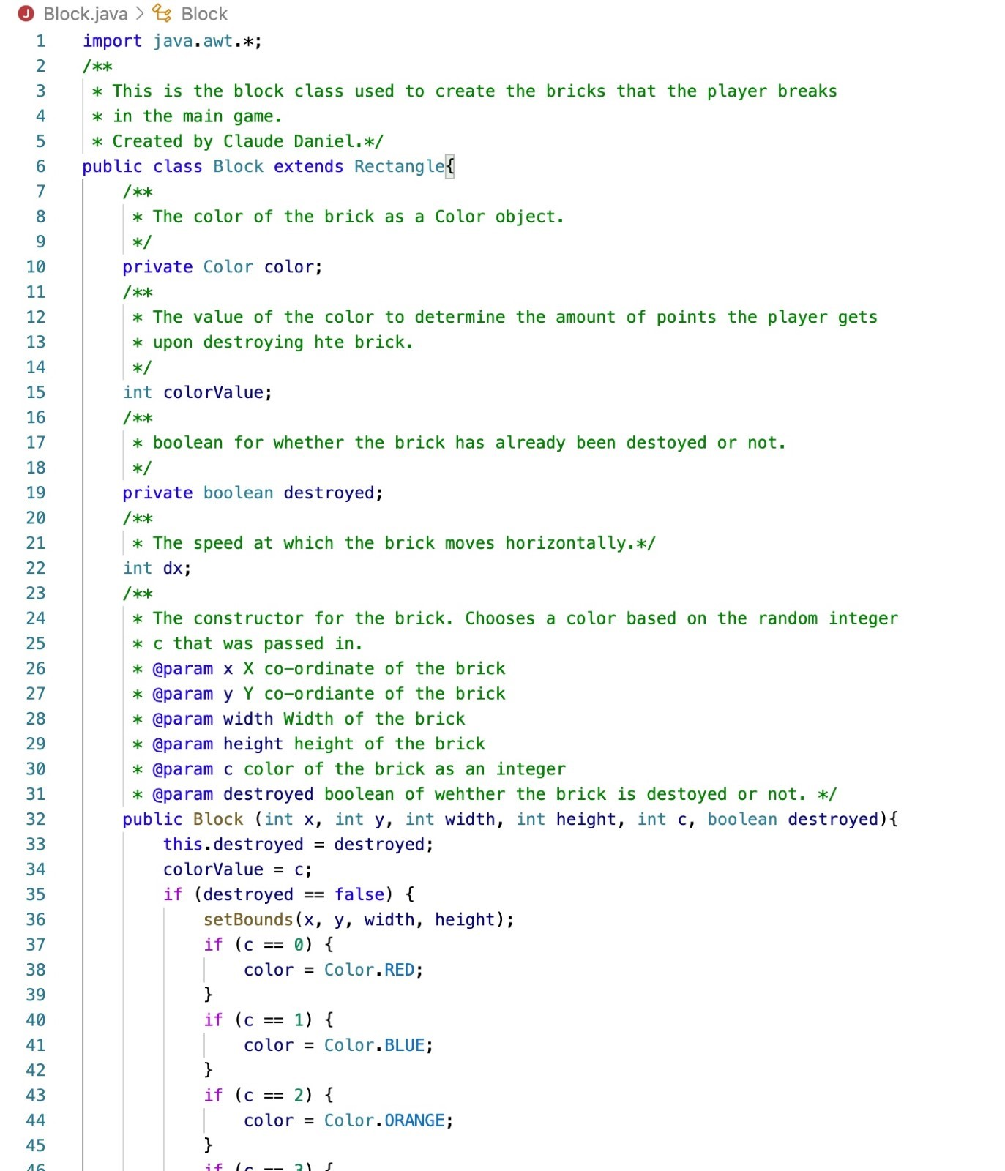

|  |
| --- |
| Block.java |

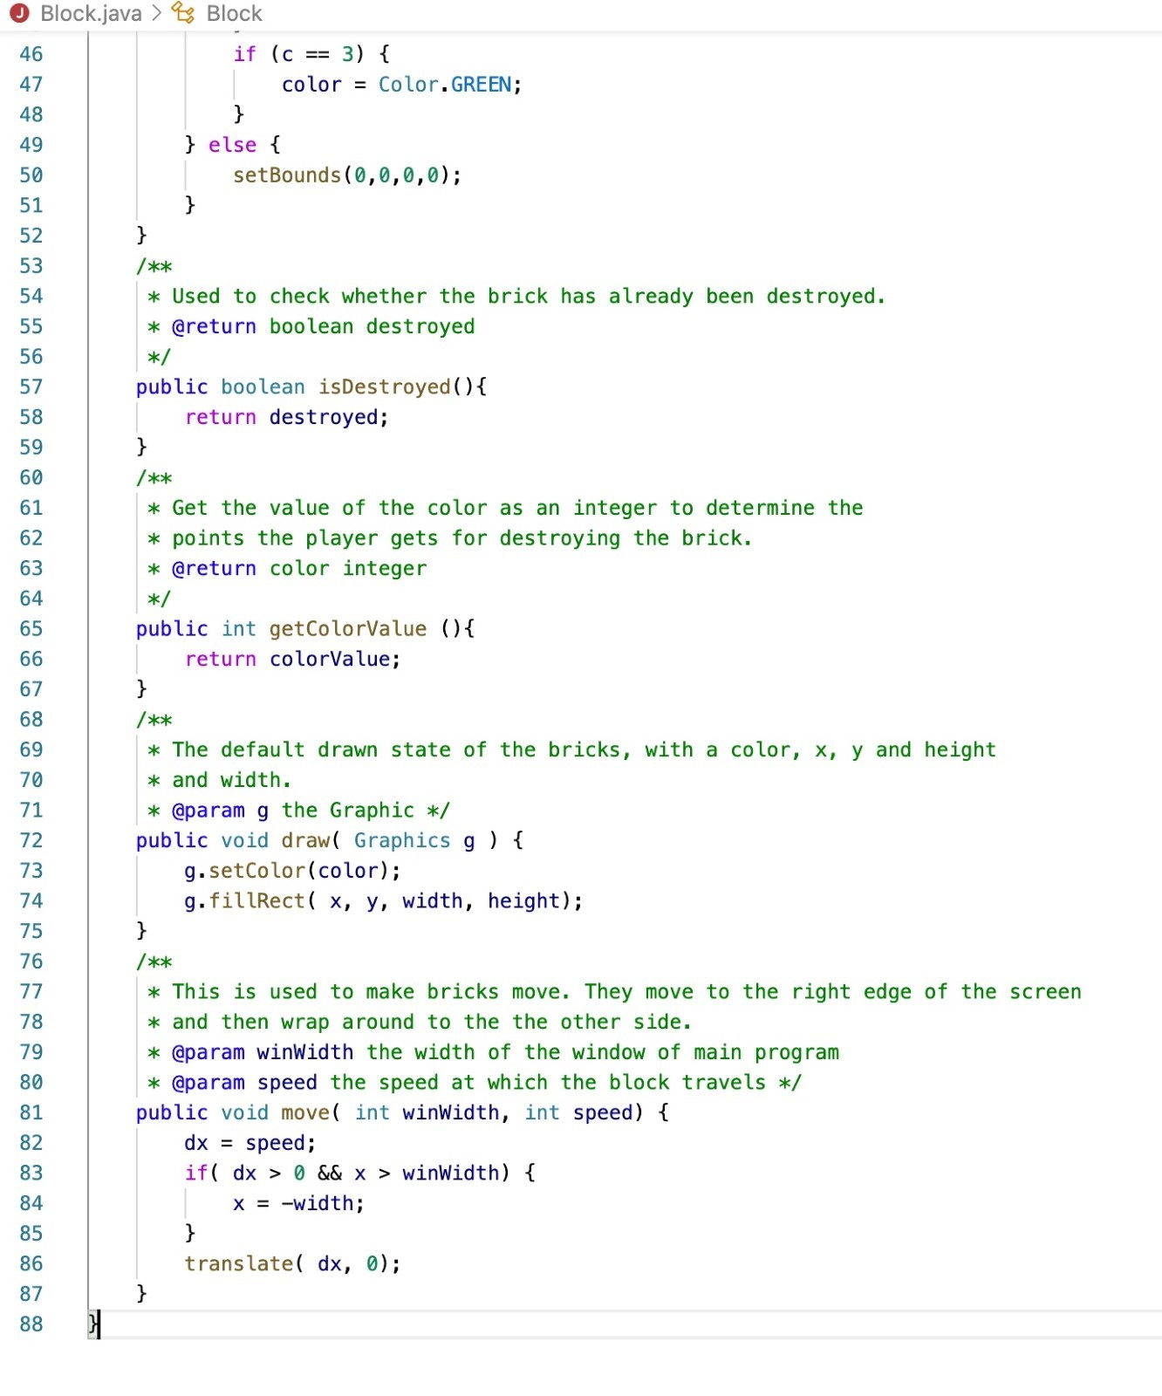

|  |
| --- |
| *Paddle.java* |

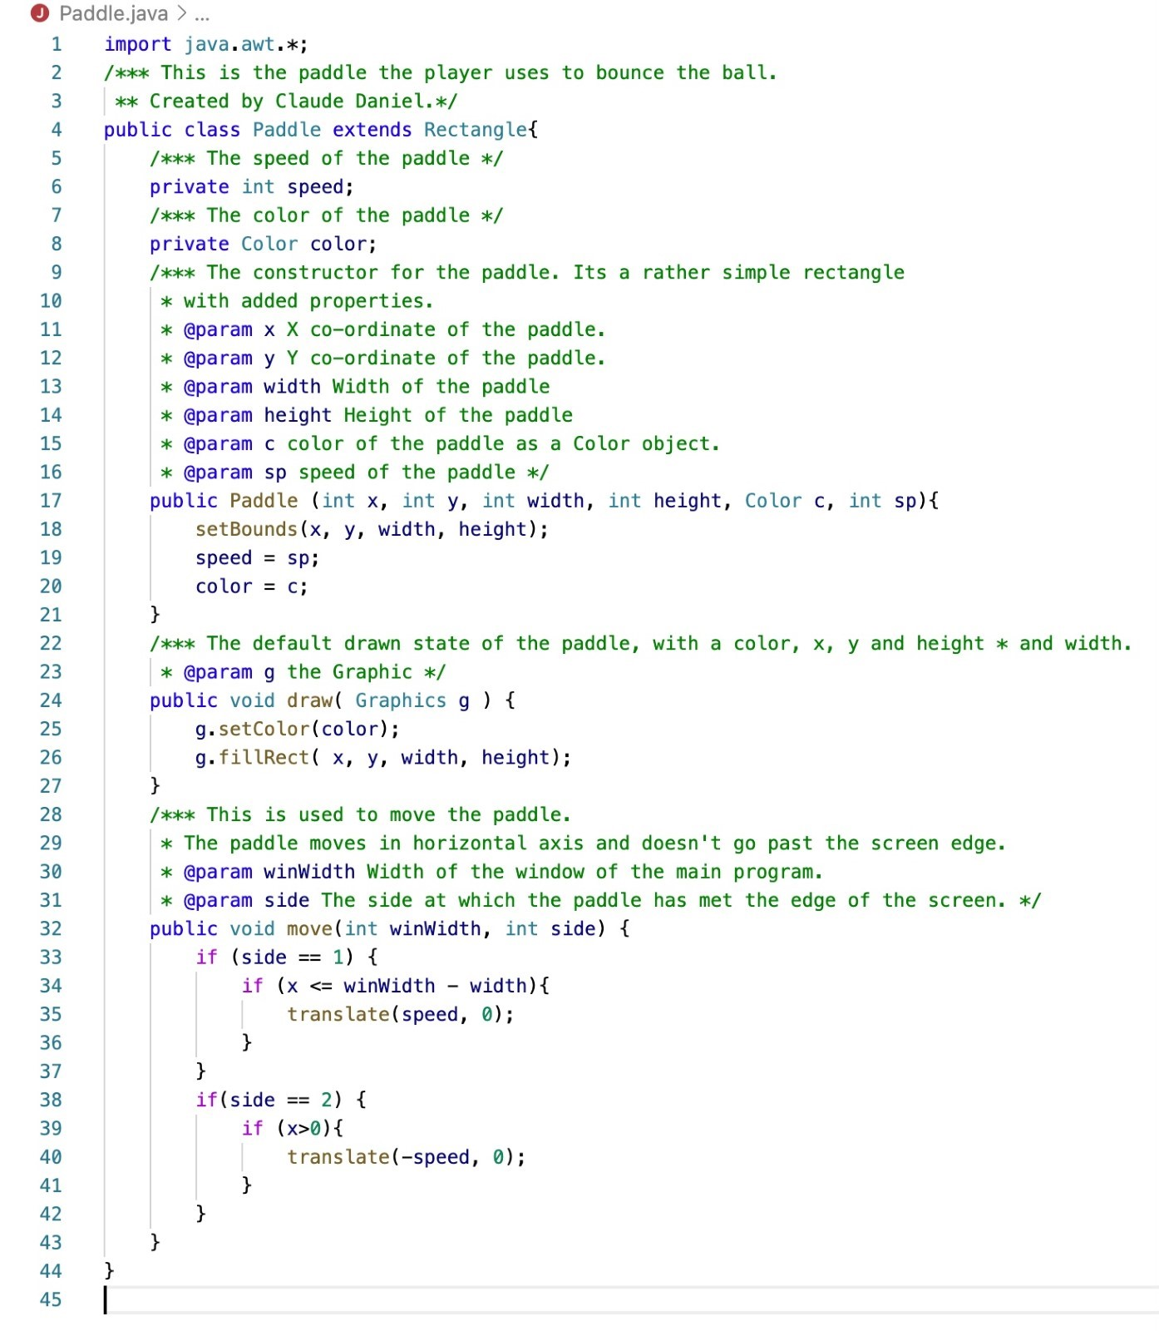

|  |
| --- |
| Window.java |

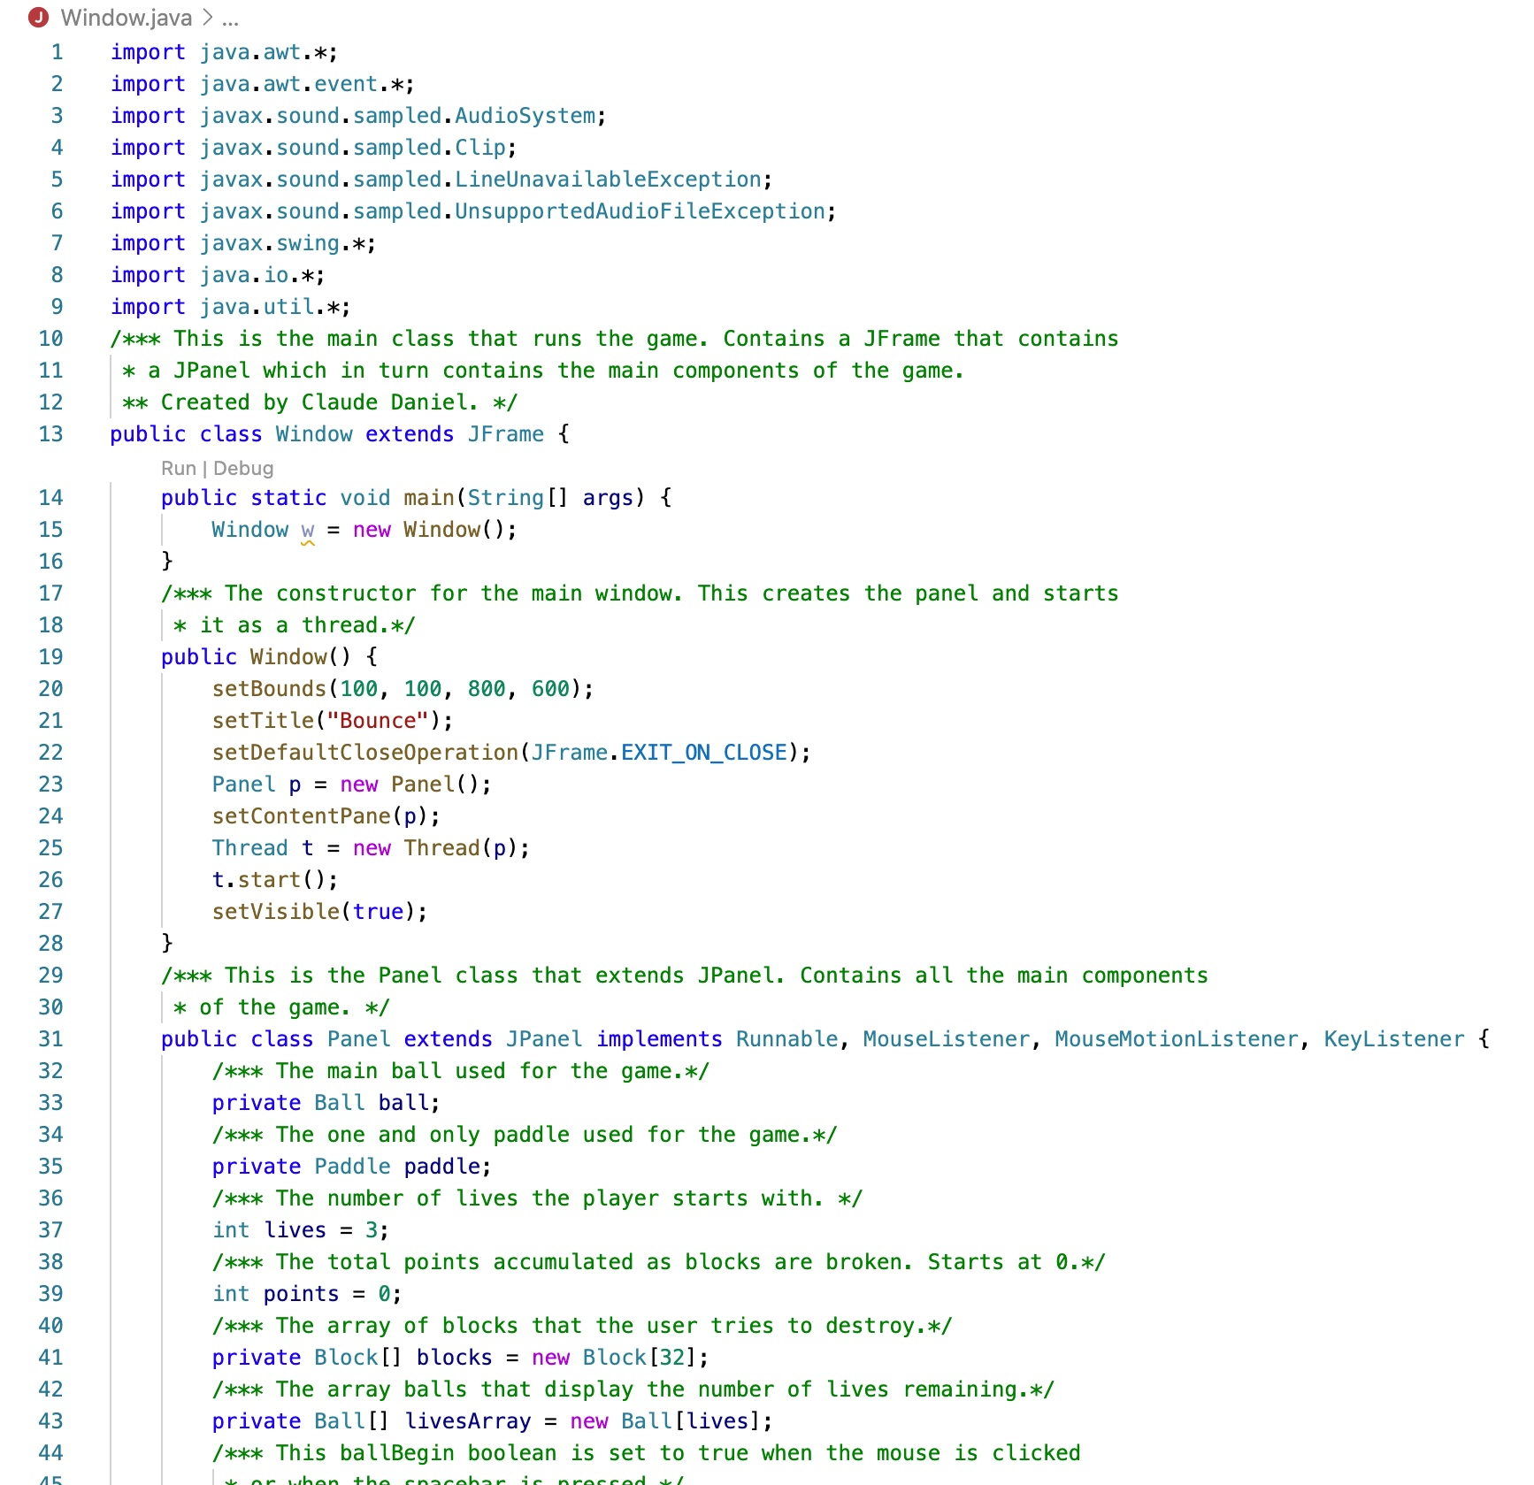

|  |
| --- |
| Window.java |

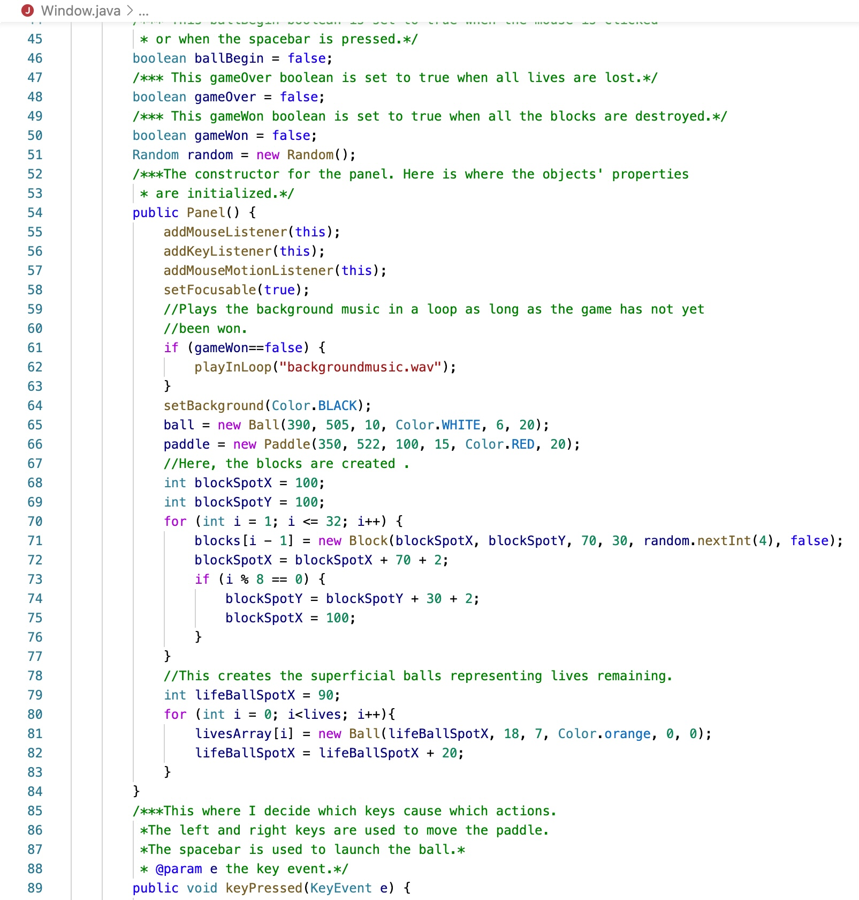

|  |
| --- |
| Window.java |

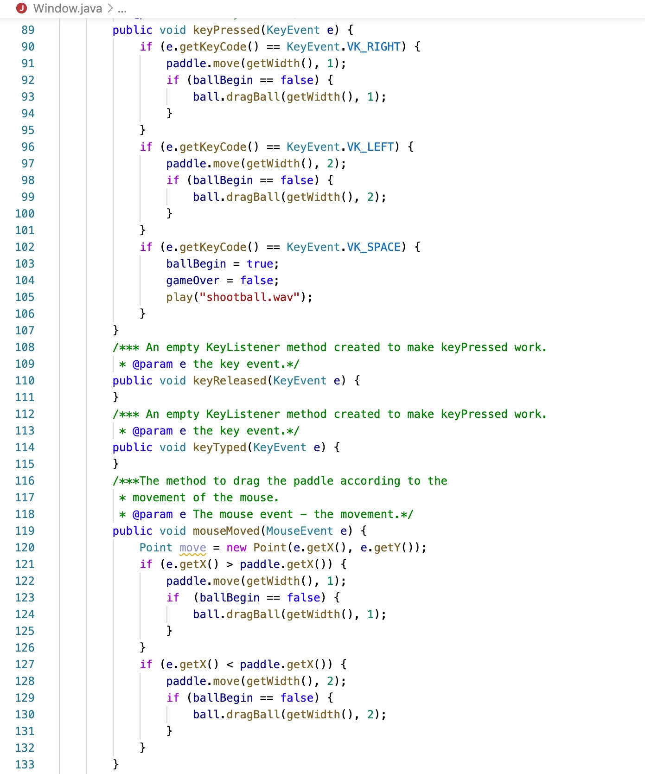

|  |
| --- |
| Window.java |

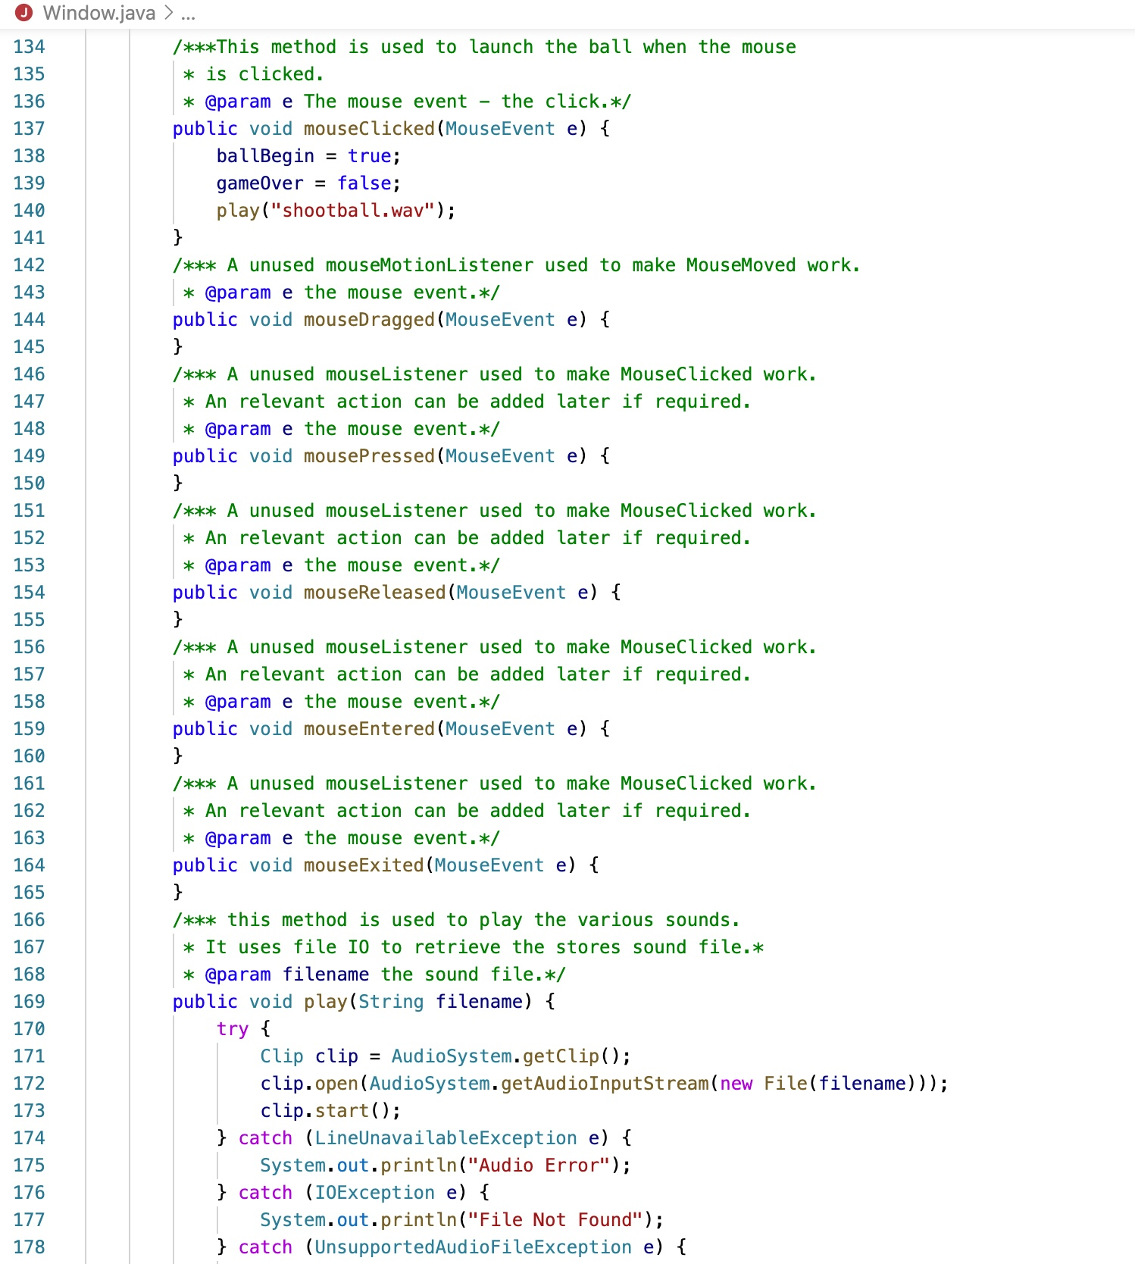

|  |
| --- |
| Window.java |

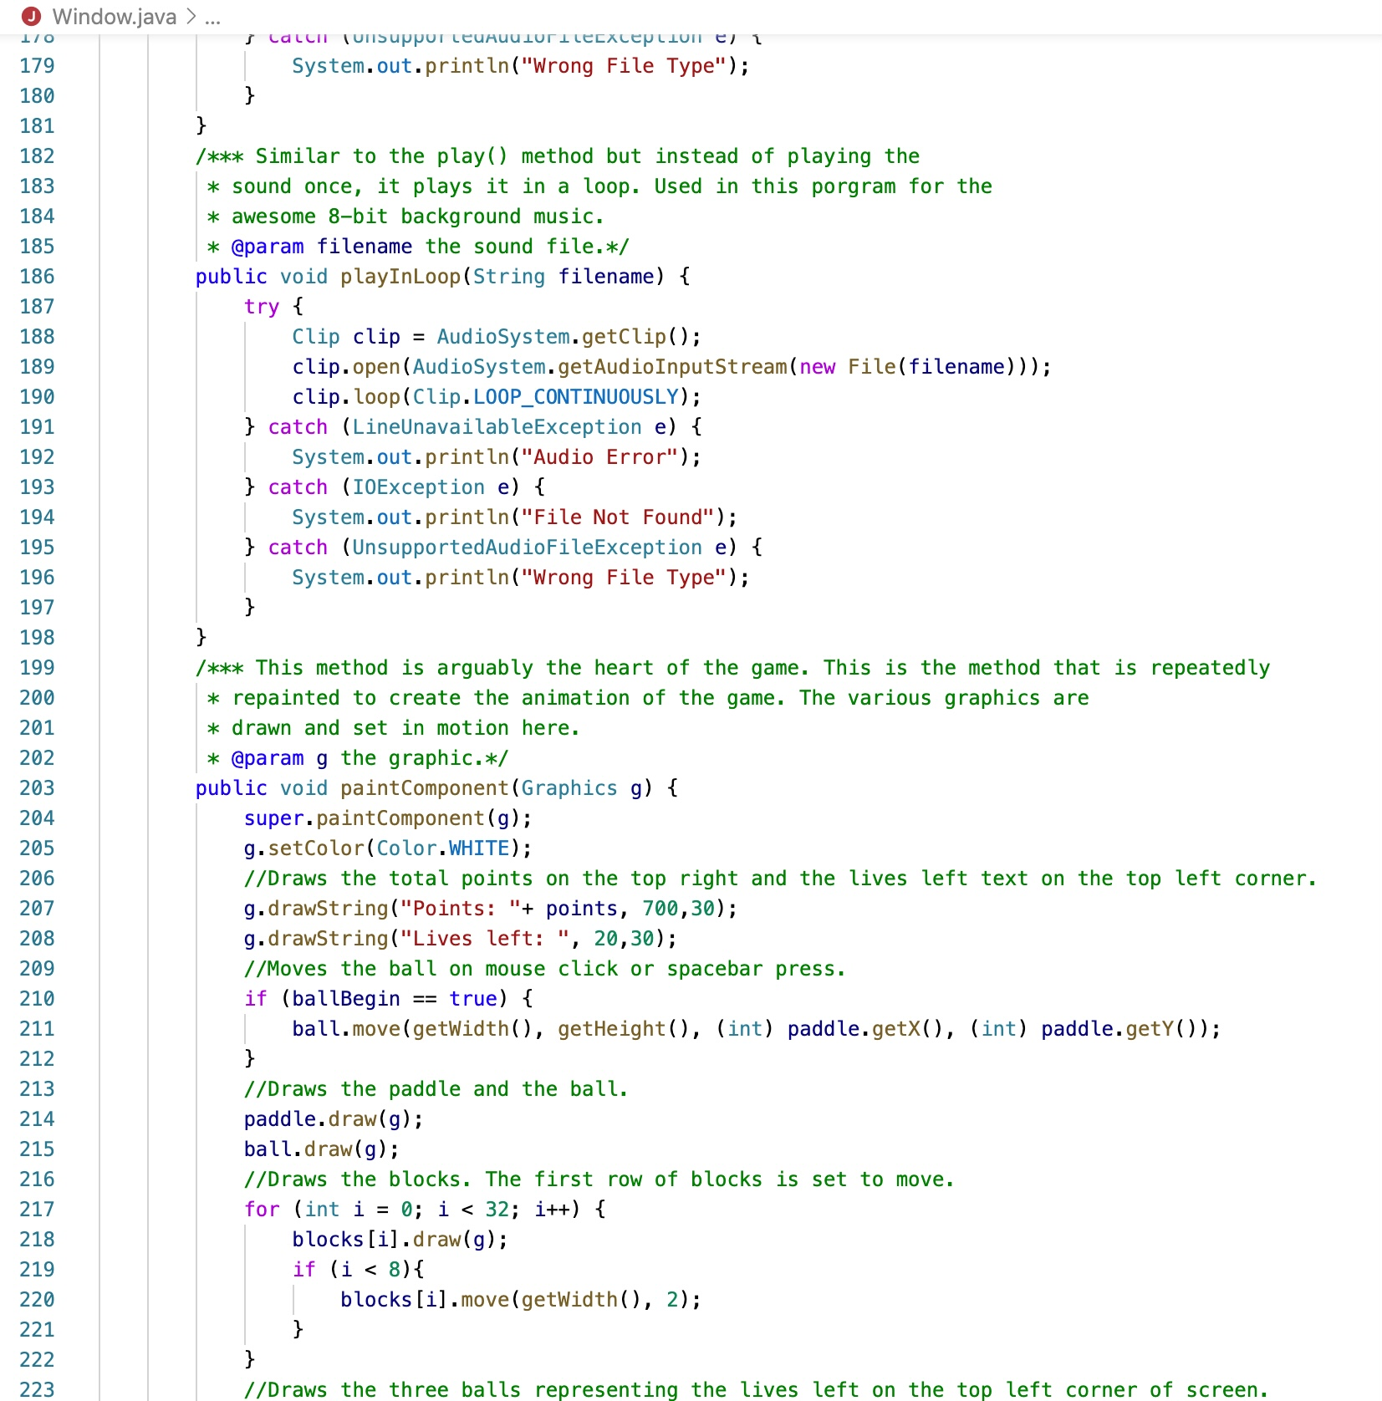

|  |
| --- |
| Window.java |

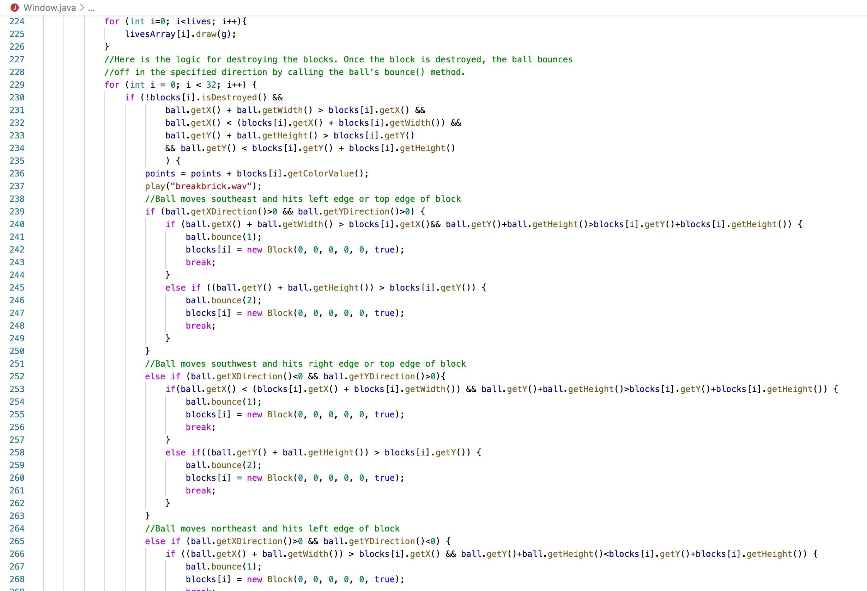

|  |
| --- |
| Window.java |

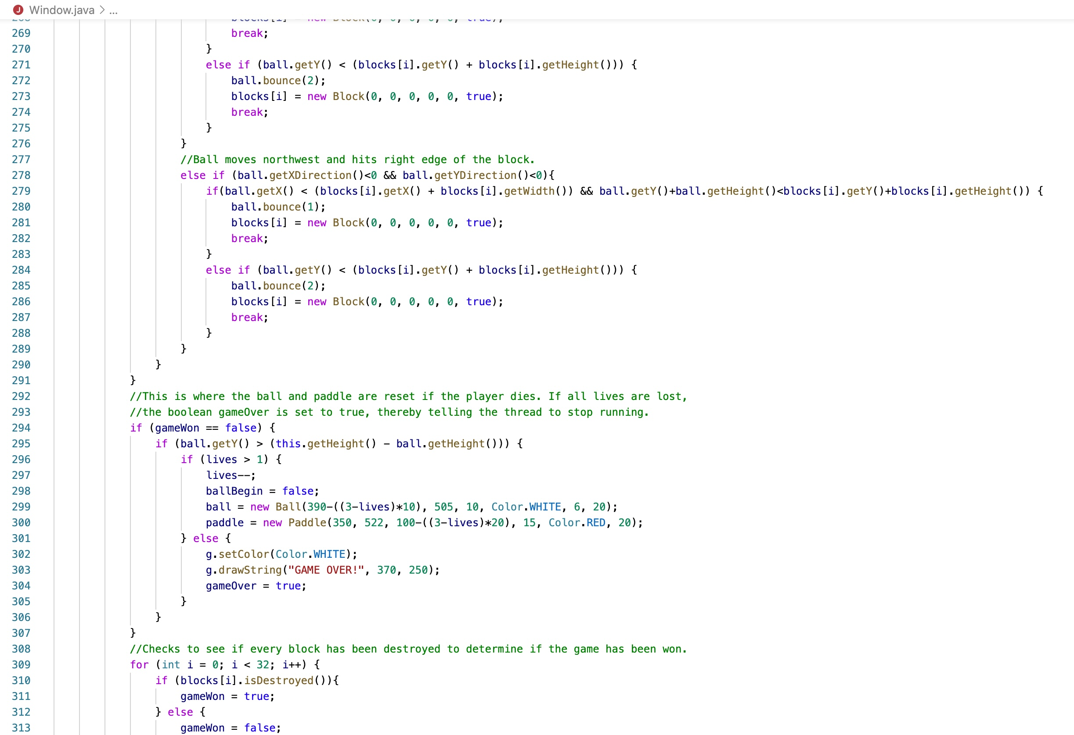

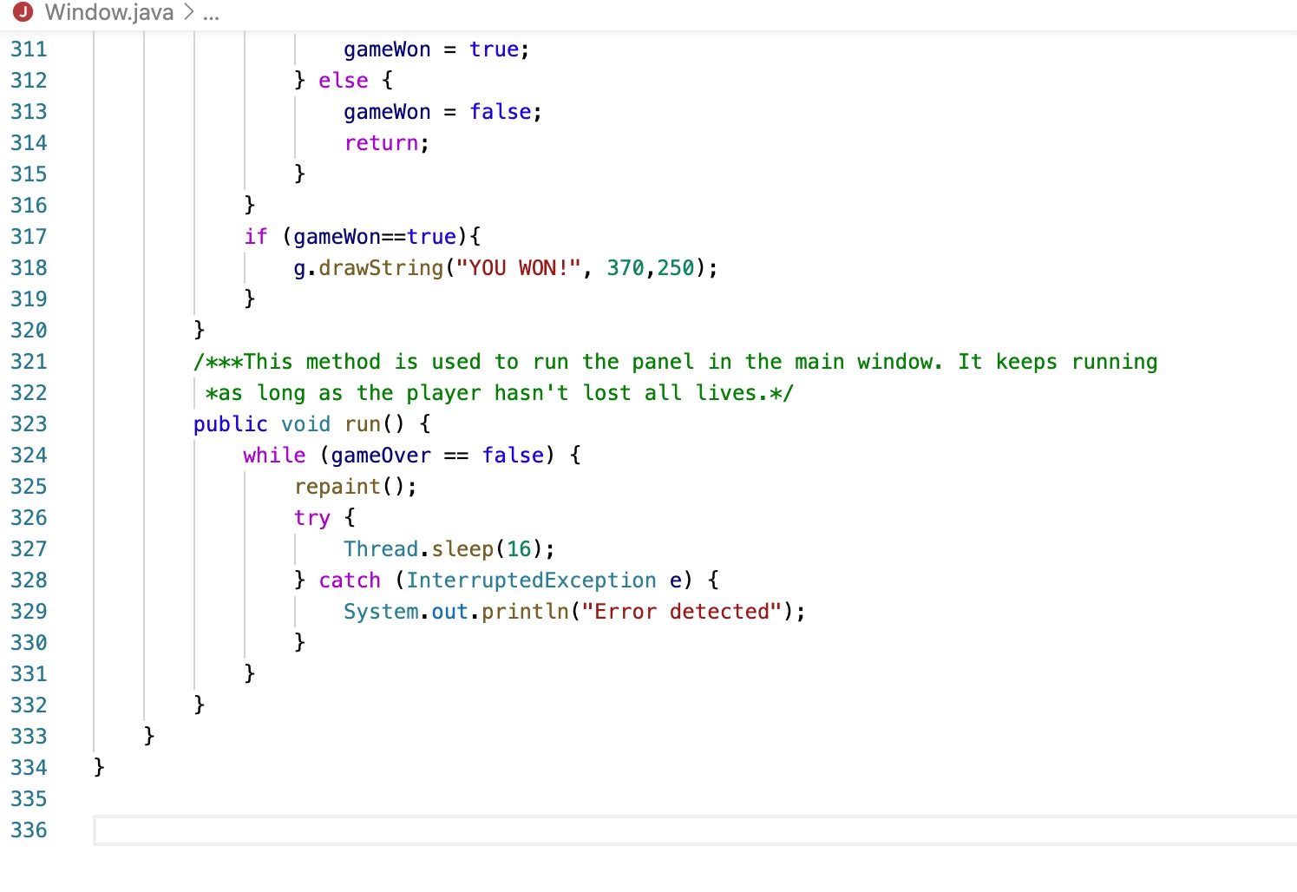

Thank you so much for being interested in our project ,hope you have fun <3